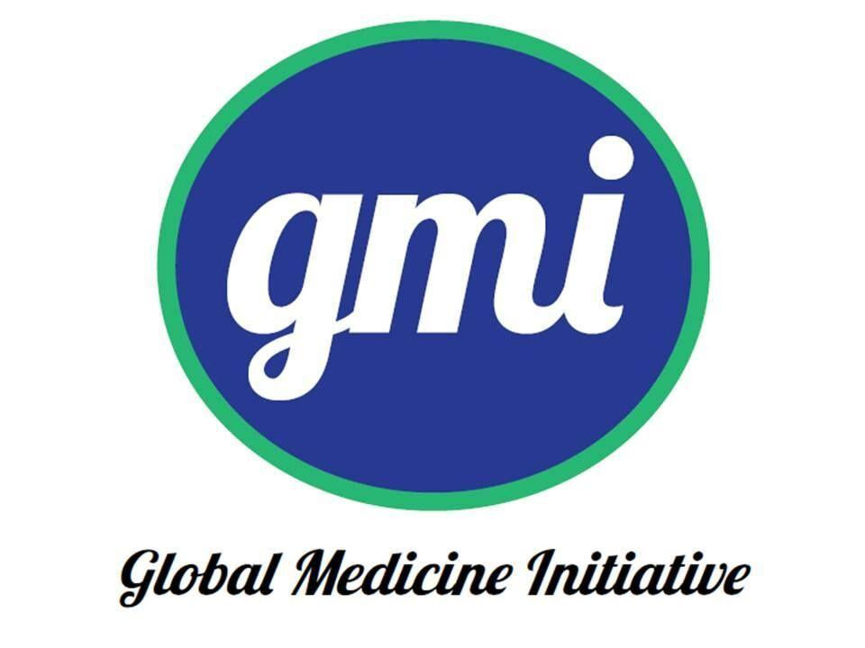
GLOBAL MEDICINE INITIATIVE
Leslie Dan Faculty of Pharmacy
University of Toronto
144 College St – Toronto, Ontario – M5S 3M2

Constitution 2019-2020
Article 1 Mission Statement and Vision
Article 2 Definitions
Article 3 Membership
Article 4 Composition and Duties of Executive Committee
Article 5 Composition and Duties of Advisory Committee
Article 6 Handling of Finances within the Global Medicine Initiative
Article 7 Meetings
Article 8 Elections
Article 9 Amendments

ARTICLE 1- MISSION STATEMENT AND VISION

1. The Global Medicine Initiative will:
a) Promote awareness and education regarding issues affecting
medicine access and health care
b) Advocate for health and access to medicines at the local, national and international levels
c) Provide social, interactive and professional learning events
d) Facilitate awareness of and financial support for international
internships and APPE placements for Leslie Dan Faculty of Pharmacy students, in collaboration with the Leslie Dan Faculty of Pharmacy
e) Support established and pioneer new global medicine and health care access projects for those in need
f) Promote a positive image for the University of Toronto and Leslie Dan Faculty of Pharmacy through community and international involvement

ARTICLE 2- DEFINITIONS

1. The name of the group shall be the Global Medicine Initiative.
2. “GMI” hereafter refers to the Global Medicine Initiative.
3. The name of the institution shall be the Leslie Dan Faculty of
Pharmacy, within the University of Toronto.
4. “LDFP” hereafter refers to the Leslie Dan Faculty of Pharmacy,
within the University of Toronto.
5. “GMI members” will be used interchangeably with the terms
“executive members” and “members”.
6. a) A committee is defined as a group consisting of at least three
members.
b) A committee may be composed of active or honorary
members.
c) Active members will form the “executive committee” and
honorary members will form the “advisory committee”.

ARTICLE 3- MEMBERSHIP
All members of GMI are executive members. Executive members shall be LDFP pharmacy faculty/ staff and students representing all years (1 to 4).
GMI events and activities are open to members and non-members, including all LDFP students and other University of Toronto
students. Executive members shall be either honorary or active.
a) Honorary members shall include:
i. Faculty/ staff of LDFP (hereafter referred to as “Faculty Advisors”)
ii. Returning LDFP pharmacy students who served as executive members in previous years (hereafter referred to as “Student Advisors”)
b) Active members shall be all those who attend a minimum of 60%
of executive committee meetings held in the academic year (i.e.
September 2015 – April 2016).
c) Executive members shall be elected or appointed to a position on
the executive committee.
d) There is no membership fee.

ARTICLE 4- COMPOSITION AND DUTIES OF EXECUTIVE
COMMITTEE
The executive committee shall be comprised of the following active
members:
a) The President shall:
o Oversee the operations, management and success of the group
o Be the spokesperson for the group
o Hold signing officer authority along with the Treasurer for
financial purposes
o Preside overboard meetings as well as general meetings
o Ensure transition of office to future executive members
b) The Vice-President shall:
o Assume duties of the President in his/ her absence
o Support the president in the operations, management and success of the group
o Oversee partnerships between GMI and external organizations or university clubs
c) The Secretary shall:
o Maintains records of meetings and emails it to the members afterward, in a timely manner
o Informs each member of their approaching deadlines for assigned tasks and follows up with each member accordingly to ensure that the tasks are completed on time
o Maintains a list of all members with current email addresses and telephone numbers
o Submits and keeps records of UPS points for event attendees
d) The Treasurer shall:
o Record all financial transactions of the group
o Hold signing officer authority along with the President for financial purposes
o Maintain a budget of income and expenses along with receipts
o Advise members on the financial health of GMI
o Support the President in preparing budgets for specific events and applying for funding
o Support other executive members in the planning and execution of GMI events
e) The Event Co-ordinators shall (2):
o Collaborates with the rest of the committee members to create a list of tasks that need to be completed to successfully execute each event
o Maintain a list of all events, their deadlines and ensuring that space is booked accordingly, and that presence of external contacts and guests have been verified
o Makes all necessary purchases for the events and informs the Treasurer in a timely manner to arrange for reimbursement
o Collaborate with External Affairs Coordinator to plan fundraisers
f) The Webmaster (1) shall:
o Update the GMI website, Facebook and Twitter accounts to keep students and faculty informed about GMI events
o Runs GMI Facebook account/page and relays Facebook messages to executive members
o Support other executive members in the planning and execution of GMI events
g) The Class Representatives (2 for Year 1 class, 1 for Year 2 class, 1 for Year 3 class) shall:
o Promote GMI goals, events and activities amongst their class
o Facilitate discussion between their class members and the
executive committee
o Support other executive members in the planning and execution of GMI events
o Collaborates with other class reps to create monthly blogs/ interesting articles that relate to Global Medicine
h) The External Affairs Coordinator (1) shall:
o Communicate collaboration ideas and event details with GMI’s
external partners including community and non-profit
organizations, university clubs and LDFP sponsors
o Research potential recipients of funds collected from GMI
fundraisers
o Support other executive members in the planning and execution of GMI events
Termination of Executive Members:
Any member of the club who commits an act negatively affecting the interests of the club and its members, including non-disclosure of a
significant or continuing conflict of interest, may be given notice of
removal.
The member up for removal shall have the right to defend his/her
actions. A 2/3 majority vote of the current members present in favor of removal is required.

ARTICLE 5- COMPOSITION AND DUTIES OF ADVISORY
COMMITTEE
The advisory committee shall be comprised of the following honorary
members:
a) The Student Advisors shall:
o Attend as many executive committee meetings as possible to
advise members on event ideas, implementation and logistics
o Provide suggestions and/ or tips to the President and Vice-
President based on past experience on the executive committee
o Support other executive members in the planning and execution of GMI events
b) The Faculty Advisors shall:
o Provide ideas to the President and Vice-President on events that should be implemented by GMI, including fundraising and
speaker suggestions, and networking opportunities with various
individuals, organizations and student clubs
o Relay information regarding APPE requirements and available
international placements for Year 3 LDFP pharmacy students
through GMI
o Support GMI in the implementation of the annual fundraising
Gala event

ARTICLE 6- HANDLING OF FINANCES WITHIN THE GLOBAL
MEDICINE INITIATIVE
The Secretary/ Treasurer shall keep records of all income and expenses and shall, whenever requested by executive members, present the group’s financial health.
The group’s members may not engage in activities that are essentially commercial in nature. This is not intended to preclude the collection of charges for specific activities, programs or events, or to prohibit groups from engaging in legitimate fundraising. However, the group will not have as a major activity a function that makes it an on-campus part of a commercial organization, will not provide services and goods at a profit when that profit is used for purposes other than those of the organization, and will not pay salaries to some or all of its officers.

ARTICLE 7- MEETINGS
The executive committee shall meet on a monthly basis for
approximately 1 hour per month. A minimum of 5 executive meetings
are to be held per academic year (i.e. September 2015- April 2016) to
review logistics, assign duties and plan details for upcoming GMI
events. Dates, times and locations will be scheduled and announced by
the President. The quorum of executive meetings shall be 50% of
executives.
Meetings with the advisory committee shall be held whenever
necessary, and shall include the President, Vice-President, Student
Advisors and at least one Faculty Advisor. Members of the advisory
committee may attend any executive committee meetings.

ARTICLE 8- ELECTIONS
The current President and Vice-President shall nominate 2 executive members to the President and Vice-President positions of the following year’s executive team, based on submitted applications. The new President and Vice-President shall then, using a majority voting system in collaboration with the current President and Vice-President, select new executive team members based on submitted applications from LDFP pharmacy students. Pharmacy students in all years may apply for executive positions. Returning executive members who apply for executive positions will always be given priority in the selection
process.

ARTICLE 9- AMENDMENTS
Any past or present GMI executive member may propose and vote on amendments to this constitution. The executive committee will
administer the process of having amendments discussed at general
meetings.
Constitutional amendments shall require a 2/3 majority to be passed by members in attendance at executive meetings. The executive committee shall formally adopt the new constitution and submit the revised constitution to the relevant university and LDFP offices.

